Sim Student User Documentation:

+ JAVA setup:
- Install Java JDK 5.0 http://java.sun.com/j2se/1.5.0/download-netbeans.html
- Set JAVA_HOME environment variable:
  - My Computer, right click, Properties
  - Advanced Tab, Environment Variables
  - Click New under ‘System variables’
    - Variable Name: JAVA_HOME
    - Variable Value: installed java directory
- Edit PATH environment variable:
  - My Computer, right click, Properties
  - Advanced Tab, Environment Variables
  - Select “Path” variable and click Edit
    - Add java bin directory at the end of the variable value
(Type following: ; JAVA_HOME/bin)

+ CTAT setup & Code Check out:
- Download CTAT from http://ctat.pact.cs.cmu.edu/index.php?id=download
- Check out QA module with CVS under your PACT-CVS-TREE/

+ Sim Student startup with Equation tutor:
- In the command prompt, go to QA/Tests/TestTutors/Projects/SimStEquation/
- Compile all the java files (e.g. javac *.java). If there is no necessary library files to compile files in the directory (such as DorminWidgets.jar and jess.jar), add the classpath when compile. (e.g. javac –cp YOUR_CVS_TREE\AuthoringTools\java\lib\DormminWidgets.jar;YOUR_CVS_TREE\AuthoringToools\java\lib\jess.jar *.java)
- Open Equation.sh file
- Change the path names “CVSDir” to the path for PACT-CVS-TREE/ directory on the local machine and “DorminJar” to the path for PACT-CVS-TREE/ AuthoringTools/java/lib/DorminWidgets.jar
- On a command prompt (or cygwin, emacs shell), run Equation.sh script by typing ./Equation.sh
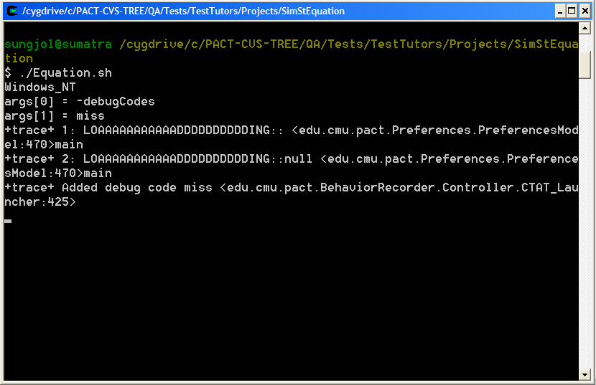
- Behavior Recorder window and Student Interface window will start running.

- Firstly activate Jess tools – jess windows will pop up. 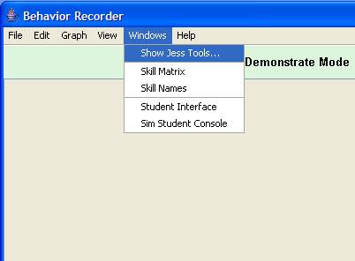

- Activate Sim Student : 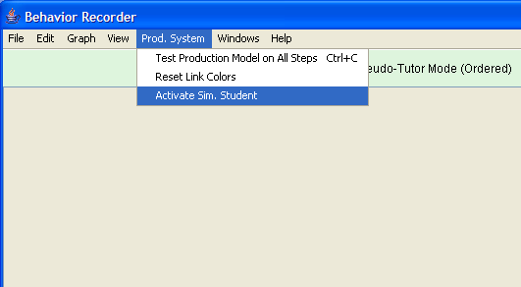

- Simulated Student Console Ver. 1.00 window will pop up.

- Start creating a new problem on Student Interface window

(e.g.): 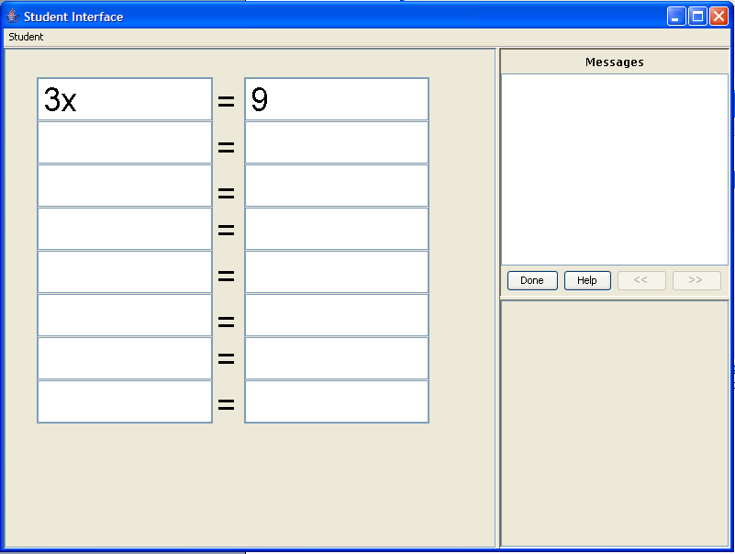

- Create a start state for the new problem: 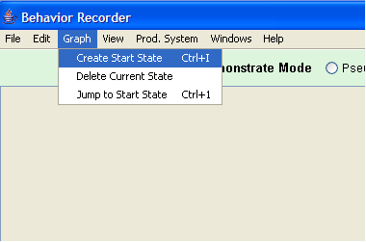

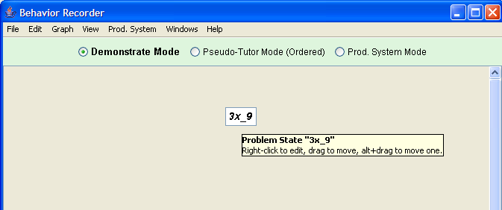

- Select the cells that would be related to solve a next step of the problem you have created. This is required in creating a production rule. For instance, to solve the next step from here, we need to have first row cells in order to solve the problem further (e.g. 3x/3 (LHS term) and 9/3 (RHS term)). If a same skill is used in other steps or other problems, selection of the previous cells should be the same. And location of cell selection would be relative to currently active cell for input. (look at example 1 at the bottom)
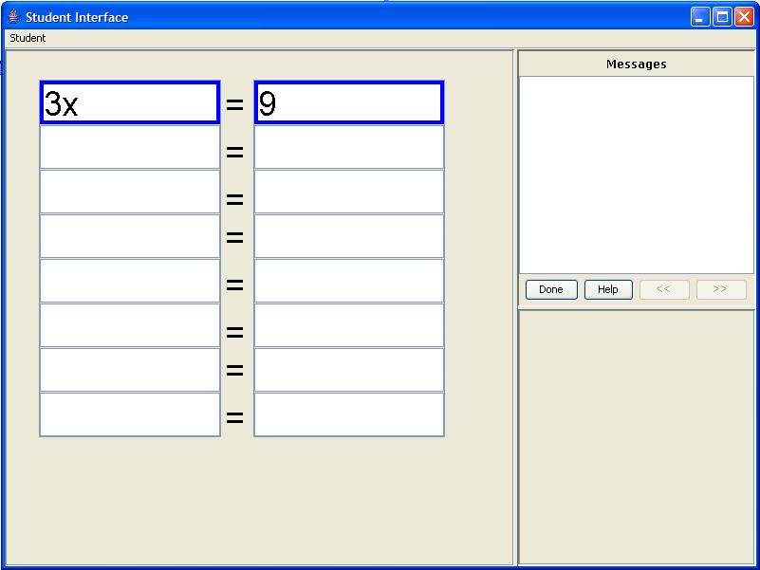

- On the next row of cells, enter values in the order of steps of solving the problem. Behavior recorder would automatically create a node and connect it with a new edge. Since there is no production rule for the first problem set, the window prompt appears to notify there is no rule for the action that is created. Red colored edge indicates there is no production rule for this action. 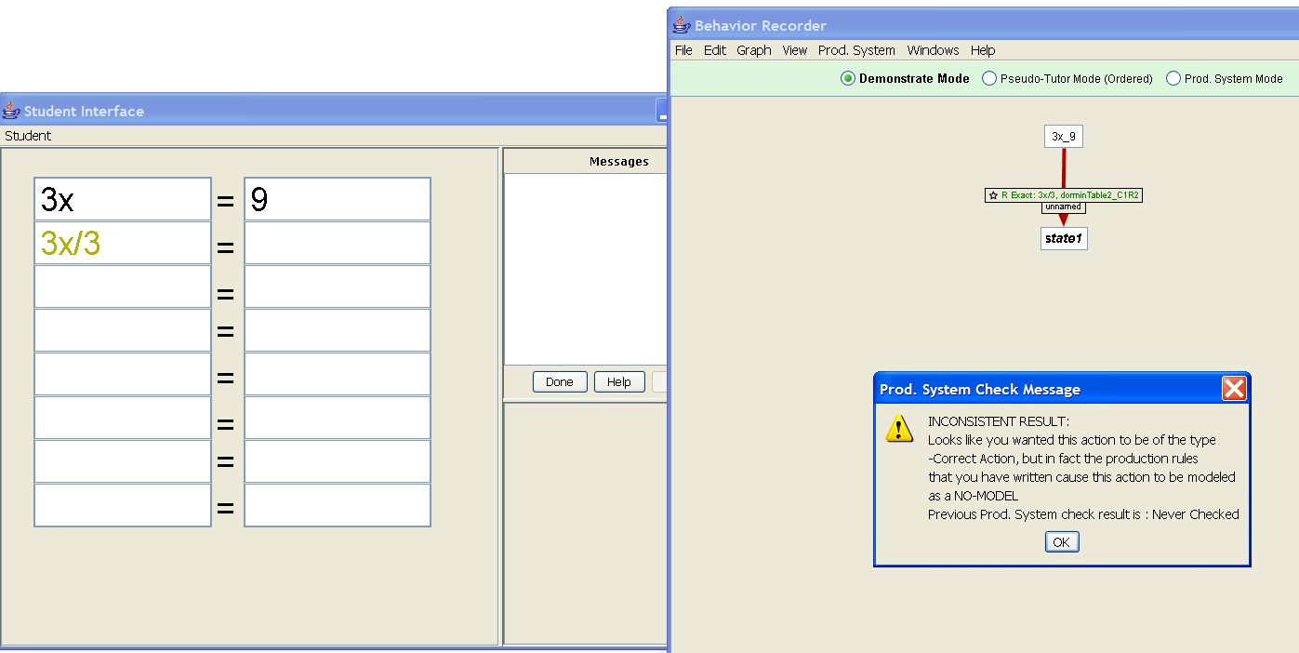

- Set the skill name and skill set of this step by right clicking on the skill name. Initially it says “unnamed” (e.g. “divide-lhs” for skill, “eq” for skill set. There is no set rule on making the rule name) .
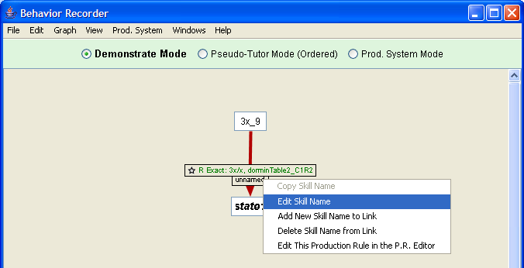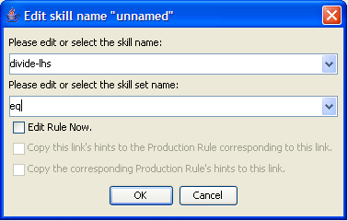 Click OK. The behavior graph skill name has been changed as following.
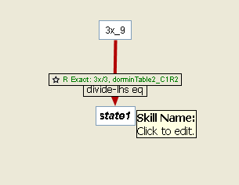

- Continue as same as 17 and 18 to finish solving the problem.

- If you wish to start a new problem, make a New Graph in the behavior recorder window. And make a New Problem in the Simulated Student Console. On the Problem tab, there is a previous problem that’s done.
- 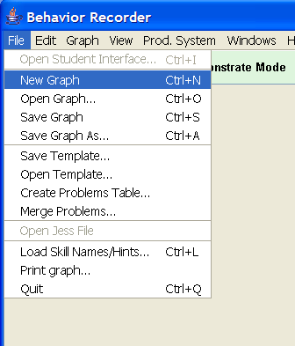
- 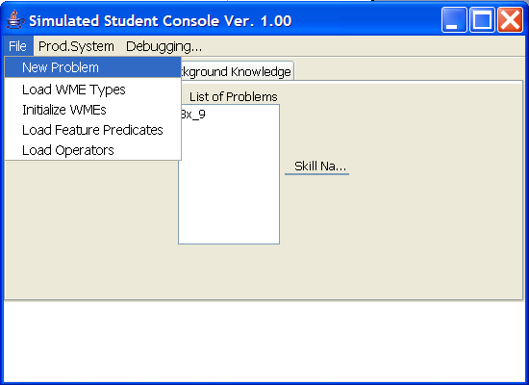

- If the new problem uses the skill that was created in the previous problems, the edge (using existing skills) of the new behavior graph would be colored green. 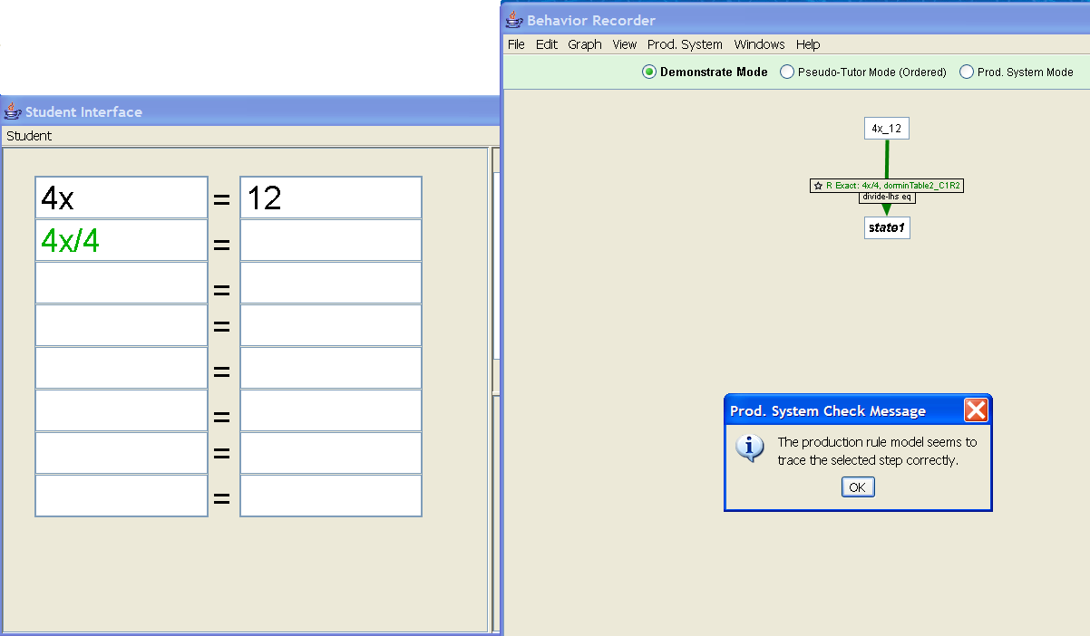Skill name has been changed because Sim student found the matching skill. 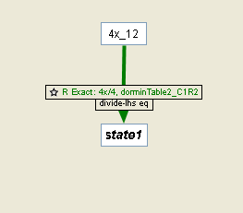
- New production files are saved under SimStEquation/PR-age/. If you change the file extension to .pr, it would be usable as production rule.

<< Example 1 >>
Problem: 3x = 9
First divide-lhs skill: Select two previous rows. You can select cells you want, but you have to make sure to select a previous cell that is related to solving the next step. For example, going to 3x/3 step requires 3x cell.
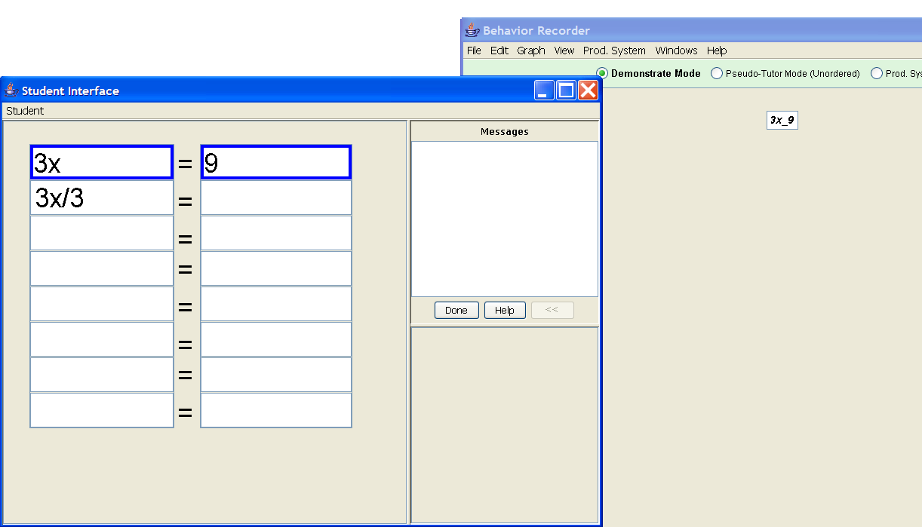

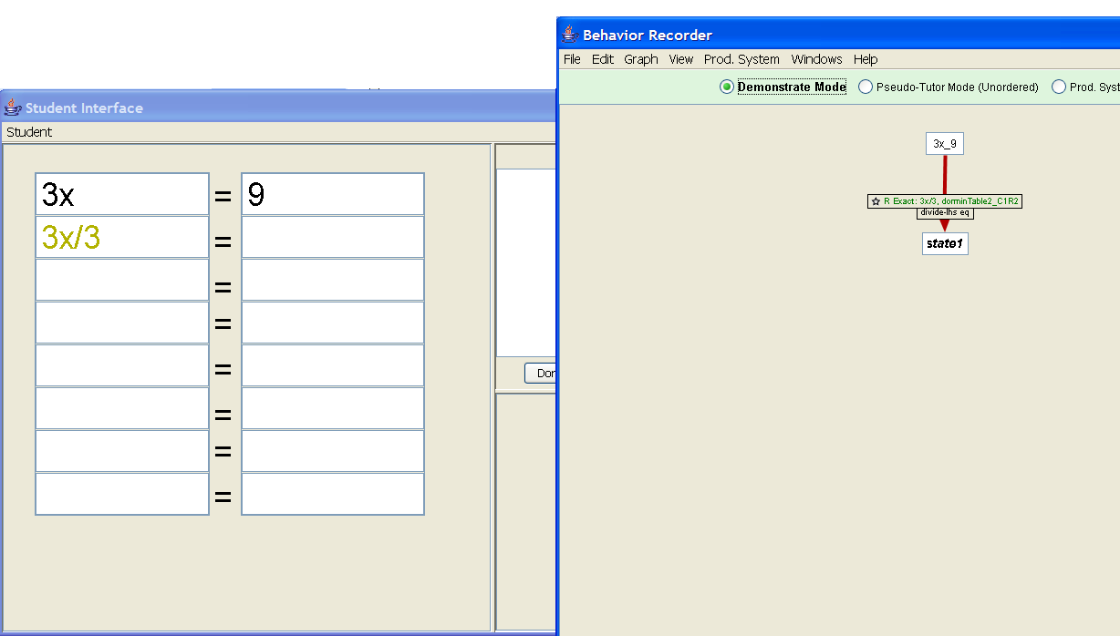

First divide-rhs skill
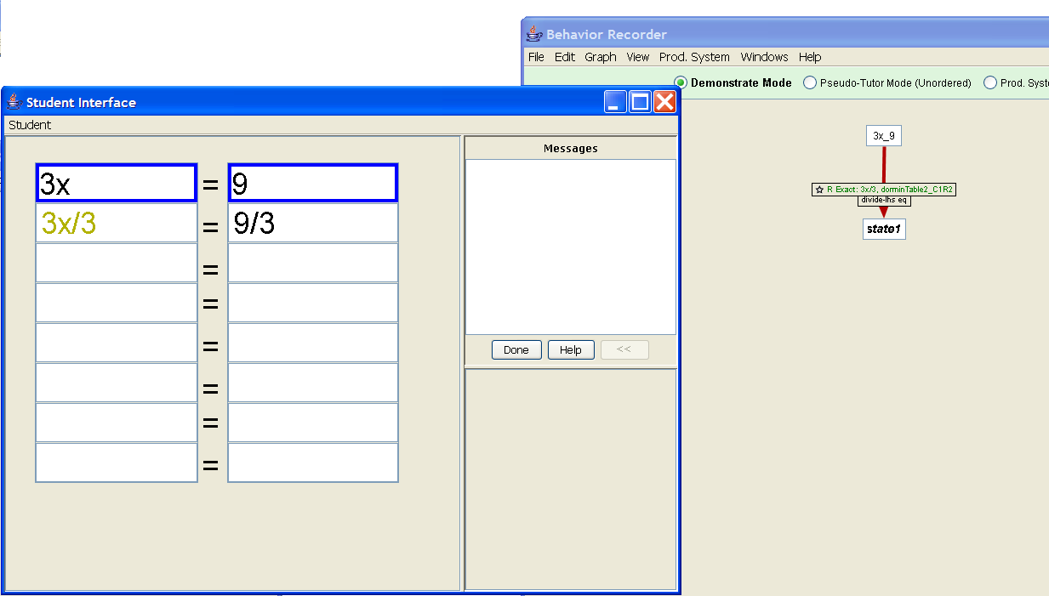

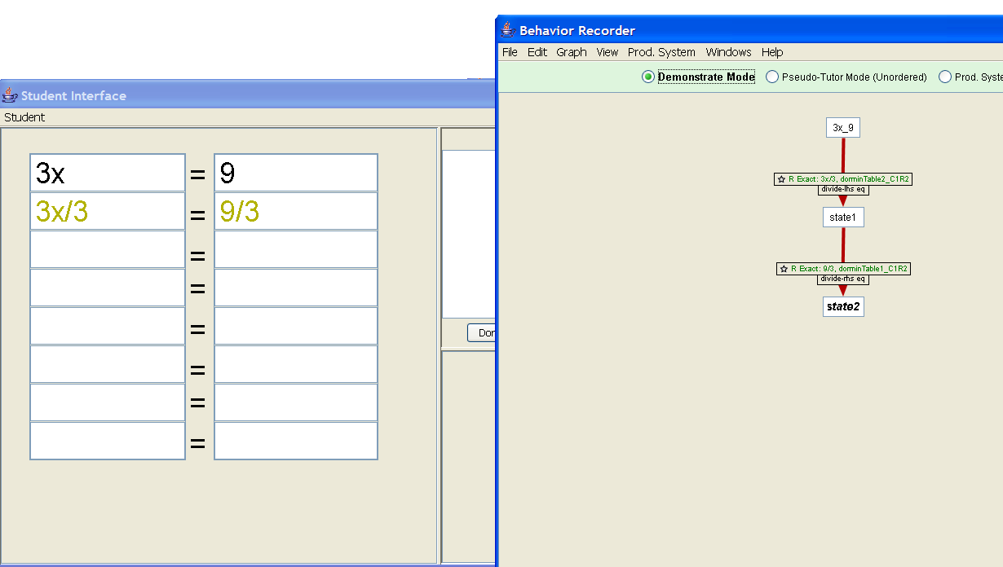

Start a New problem
Problem: 3x + 5 = 8
Subtract-lhs skill:
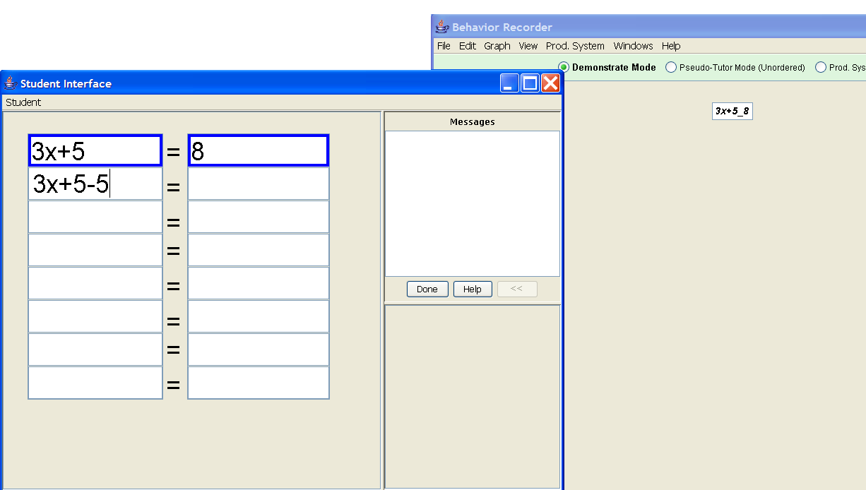

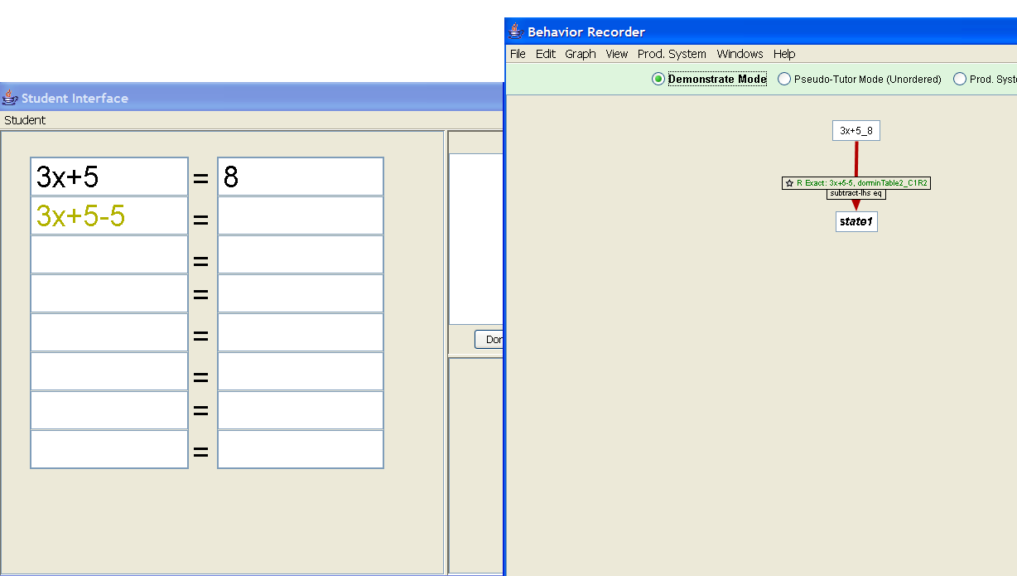

Subtract-rhs skill:
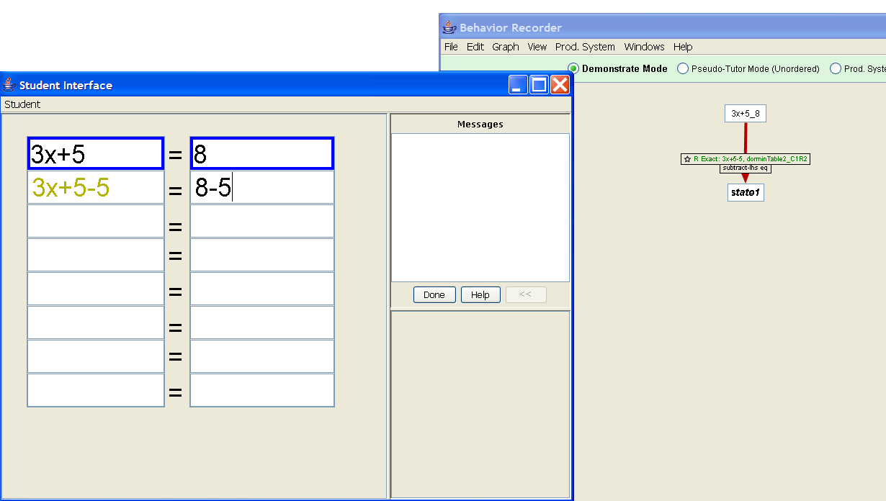

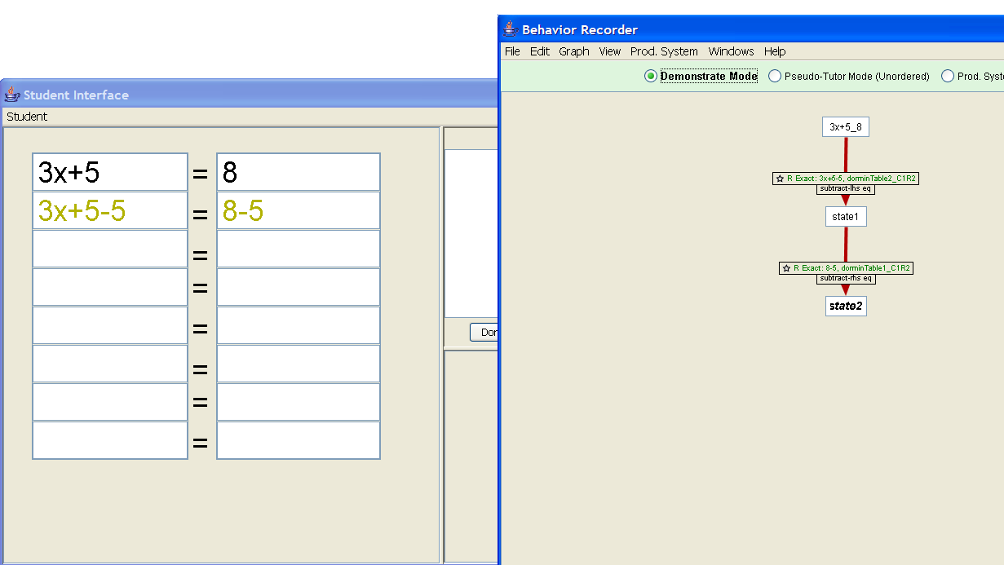

Divide-lhs skill again: Here since we selected a previous row to set this skill, we need to do the same as before, selecting the previous row. The order of setting a selection of cells does not matter, but the position of the selected cells and the current cell matters.
